Research Internship Report

Made by – Rishabh jain
Submitted to – Surbhi Upadhyay

Location- Delhi technical university , bhavana road (Precision manufacturing lab)

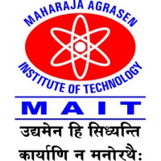

Maharaja Agrasen Institute of Technology Delhi Technical University
Rohini, Delhi-110086 (DTU)
Affiliated To
Guru Gobind Singh Indraprastha University

Acknowledgement

I would like to express my gratitude to my mentor Mr. Ramakant Rana for supporting me during the intership. His shared knowledge and experience will never be forgotten by me. The exposure I got during the internship in manufacturing, analysis, surface texturing and tribology will help me in becoming a good mechanical engineer. The knowledge of tribology and surface texturing will help me in field of manufacturing. My mentor shared his unique method of reading research papers. The knowledge is helping me in working on new subjects in research. I look forward in working with him on several research papers. The experience will open door for me to enter in the vast field of manufacturing. I would like to thank my teammates who supported me in every task. The precision manufacturing lab staff had been really helpful. During the internship I also learned how to apply my knowledge of 2-year engineering practically. I got to know about my weakness which I will work upon in near future.

Rishabh jain
Btech (Mechanical Engineering)
4th semester

Contents………………………………………….

Week 1………………………………………………………..
- Introduction
- Micro Celestron
- Image j
- Chips photos
- Cnc machine

Week 2………………………………………………………..
- Complete experiment
- Procedure of experiemnts
- Summary of research papers

Week 3……………………………………………………….
- Summary of research papers
- Deductions from research papers

Week 4…………………………………………………………
- Stir casting
- Portable stress residual stress analyzer
- Micro hardness testing machine
- Cordinate measuring Machine

Conclusion ……………………………………………………………………….

Week 1
Introduction
Short note on machines

The machines are of Three kind –
    - Surface engineering technique- sand blasting, HVOF
    - Analysis – pin on disk, x-ray residual stress analysing
    - Manufacturing- stir casting

- High velocity oxygen fuel coating(HVOF)-It is a thermal spray coating process.The method is used for surface texturing. Its benefit include longer life by increasing erosion and wear resistance.it also help in corosion protection.

APPLICATION-the method can be used for thermal barrier coatings on diesel piston engines and gas turbine blades.

- Stir casting – the method is most popularly used for casting in which material preparation(metal matrix composites and alloys) is done by melting them in stir casting furnace and casting them in desired shape.

APPLICATION- the method is used for making metal matrix composites and alloys of different metals.method is followed by mechanical mixing in molten bath.

- Sandblasting Machine – The method is used for surface smoothing,cleaining a hard surface by forcing particles across that surface at high speeds.

- High temperature rotatry tribometer-it is a test instrucment used for analysing tribologicalproperties of materials. It can also check propertiers on different temperatureranges.Is uses a pin and disk ta analyse friction.
- APPLICATION-characterizing trubological,friction and wear properties.

Micro celestron

Micro-celestron is a hand held digital microscope. It uses a 5.0 MP camera with low power consumption.the microscope can be used to click photos of coins, rocks,toolbits,gems and a lot more.The instrument can be used in wide range of applications ranging from medical , scientific research to enginerring.its magnification ranges fromn 20x to 200x.it offers wide range of photo and video resolutions.

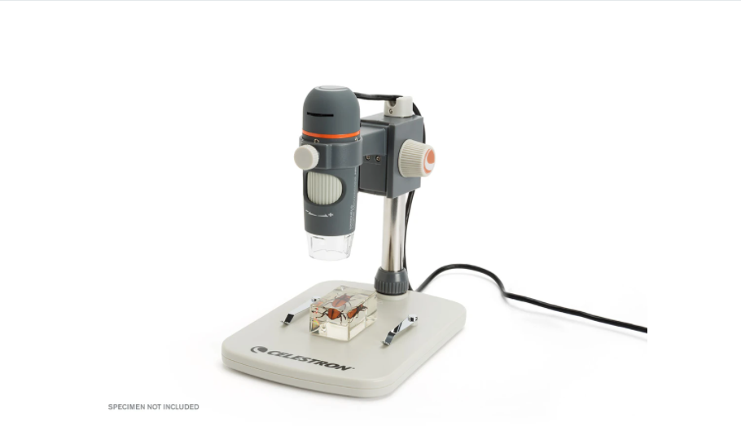
Led illuminator
Focus adjusting scroll
specimen
Hight adjustment knob

Components
- Glass lens-5-Element IR cut high-quality glass lens ensures sharper images
- USB cable - 4-foot USB 2.0 cable for easy maneuverability when viewing large surfaces
- Camera -5 MP camera capble of video recordings and high resolution photos
- Led illuminator- ring illuminator with 8 LED adjustable.
Procedure to use
- Firstly, set up the microscope by pluging the usb cable.
- Place the microscope in the frame.
- Place the specimen in frame (use holding clips if required)
- Ensure that the software is connected with the microscope
- Adjust focus according to your needs and specimen
- Click the photo using software
- Save the photo at desired location
What we did
- we used the micro celestron microscope to click photos of small chips generated from CNC machining. The photos will be used for research in tribology.
- We also used micro celestron to click photos of surface textured tool bits. Tool bits photos are clicked of all there sides.
- We click photos of tool bits with scale to further calibrate it using image j software.
- We learned to use the supporting software of micro celestron.
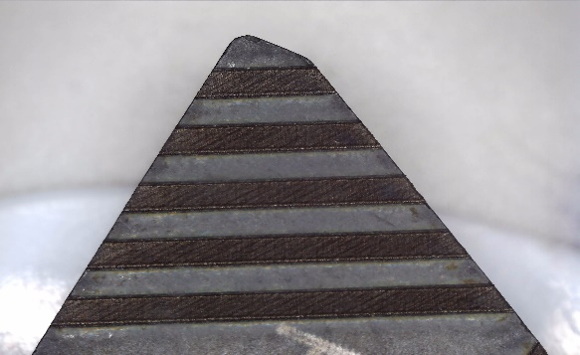
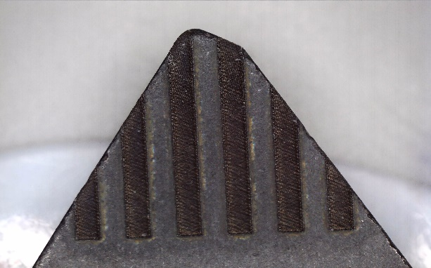
Line parallel surface texturing line perpendicular surface texturing
Image j
Image j is a softwrae which is built up on java. It is a image proceessing program.it is developed at national institute of health and the laboratory for optical and computational instruymentation.it can be edited using java plugins and recordable macros.
- The software can edit, process, save and print 8-bit and 16 bit inteher images.
- The software can edit all formats of photos like JPEG,GIF,PNG etc.
- The software can be used for calibration of images with set defined scale.
- The software works best with microscopc images with a high zoom level.

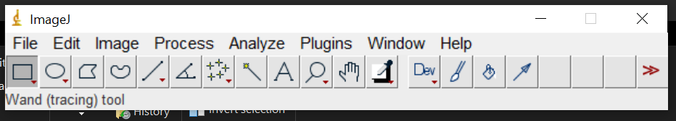
Software interface-
- File- Here you can save, exit, close and import your file.
- Edit-Here you can cut, copy and paste your file to the system
- Image- here you can make changes to the images like zoom, crop etc.
- Analyze- here you can measure, calibrate and can set scale
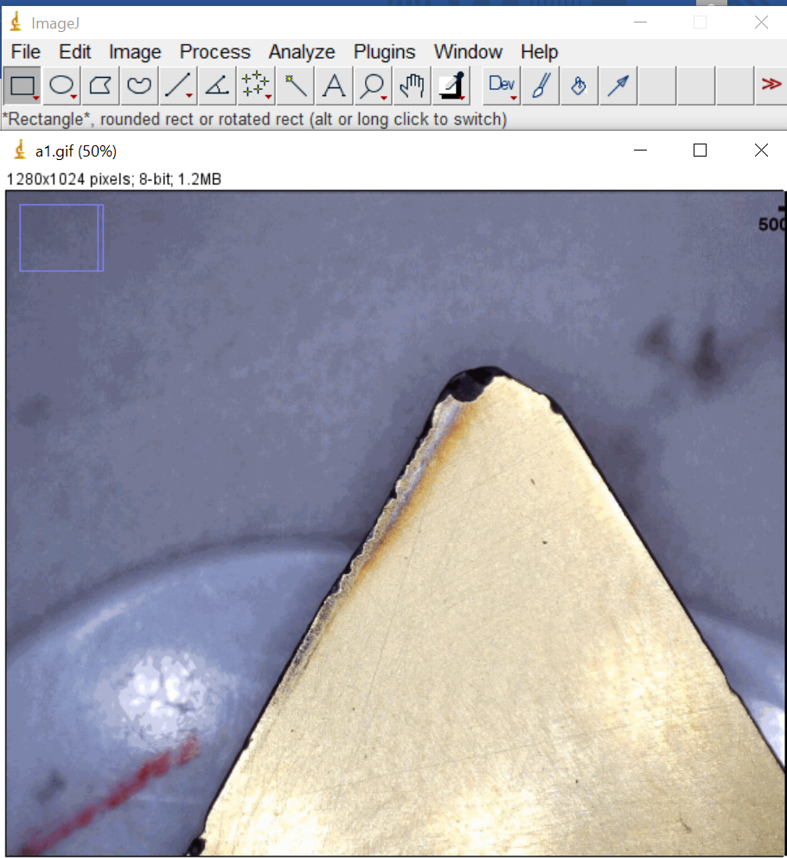
Procedure to set scale and calibrate image
- start by opening the software
- select line from main menu
- stretch a line on a known distance (usually a scale) in an image.
- go to analyze menu and click set scale
- in set scale, enter known distance and enter unit.
- Click on global to use standard for all images.
- Click ok

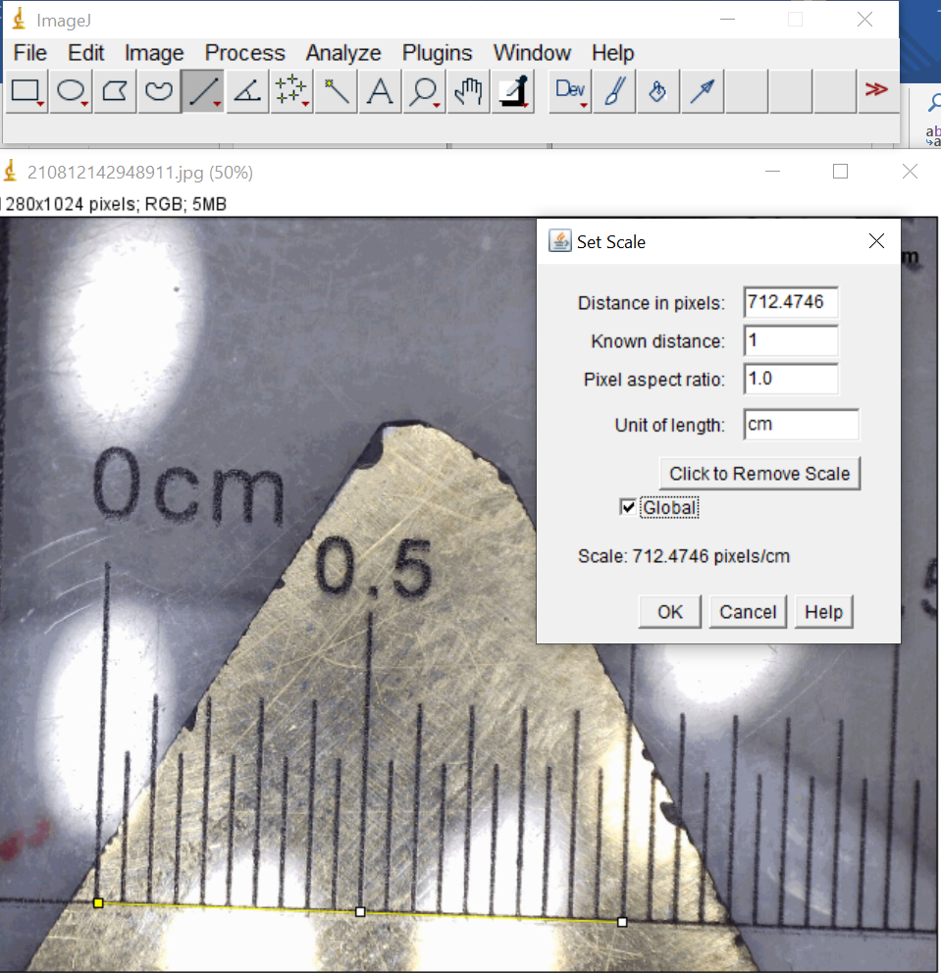
Line of known length

Set scale menu
Analyze dropdown menu
Small scale used in image for defining scale
What we did
- we used the software to first define scale
- we set a standard length (500 um ) label on all images using scale feature in image drop down menu
- we also used it for cad modeling by measuring the unknown length of tool bits and specifying them in solid works models.
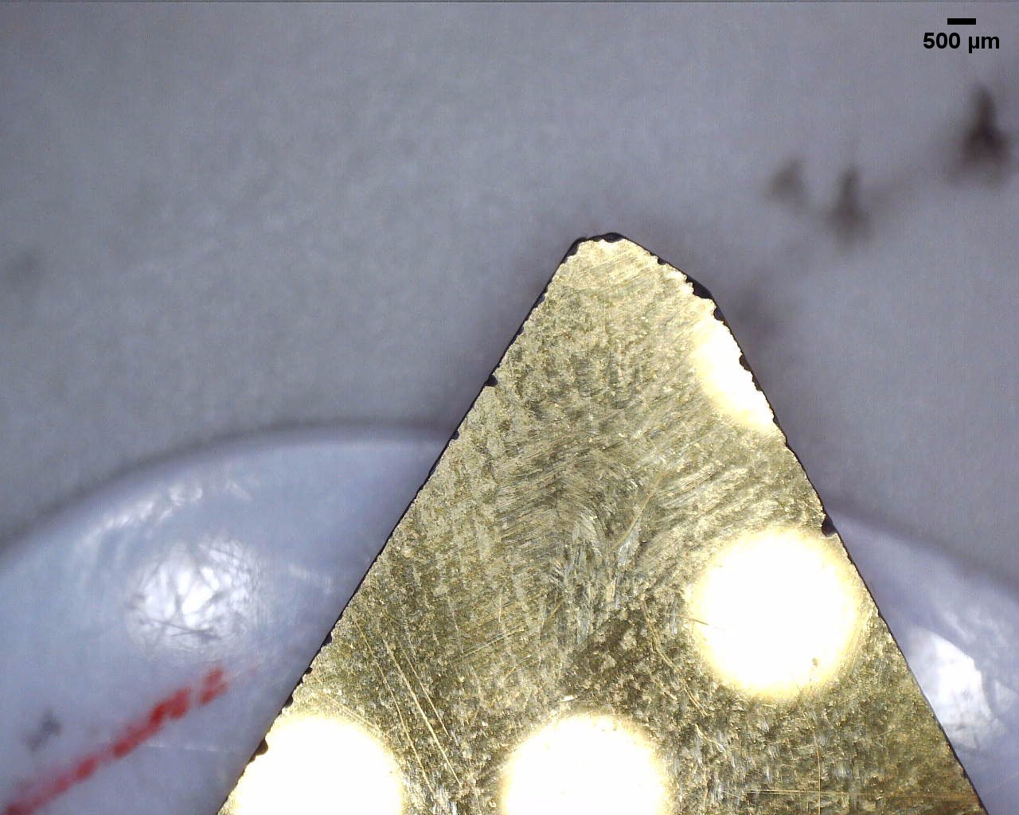
Scale bar

Chips photos

This is the collection of photos of chips that I, Abhishek and Rohit clicked during first week of internship.
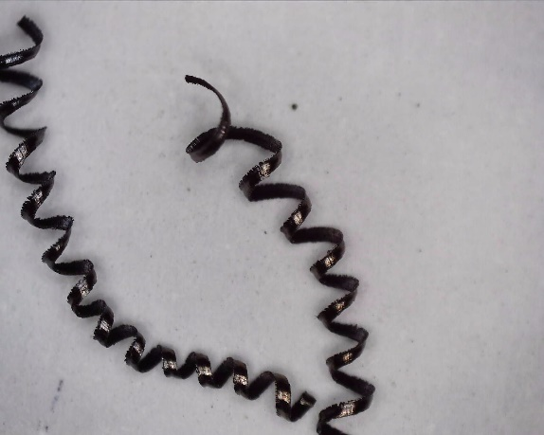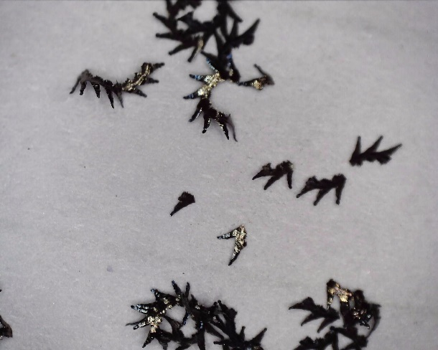

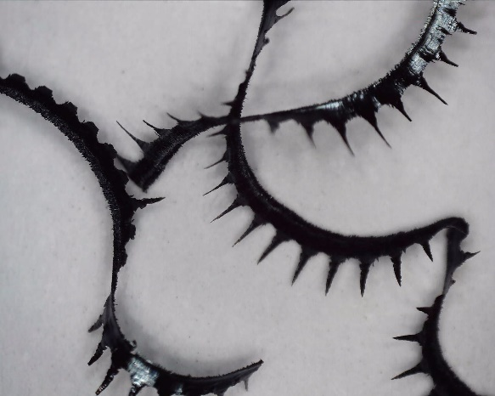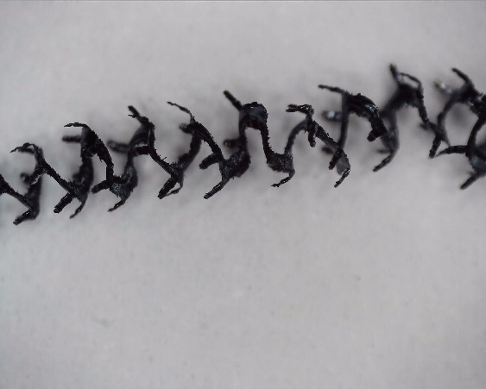

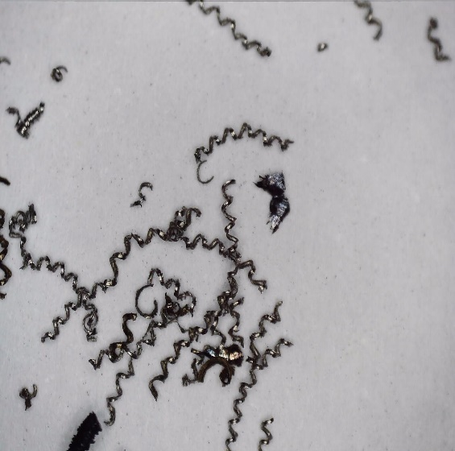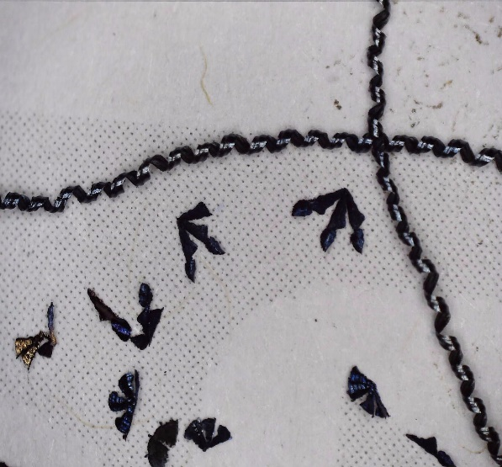

Chips are used as research evidence. Researchers use these chips photos to make deductions about tribological properties of surface textured tool bits.
Computer Numerical Control (CNC) Machine

CNC machines are the most common types of machines used for machining methods. They are mostly used in big industries and for research. They can create things of plastic, metals, aluminum, wood and many hard metals like Inconel 625.CNC works with three primary components that is command function, a drive/motion system and Feedback system.

CNC machining is the automated process driven by computer program to make a desired part out of a solid material.



LMW LL20TL3 CNC TURNING CENTER
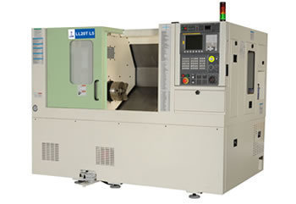
Footswitch
Tailstock
Headstock
Control
Panel
Chuck

Parts of CNC Machine

- Headstock-workpiece is attached to this part. Motor and spindle is attached to this part
- Tailstock-This part is used for support. Operations like knurling need extra support to workpiece.
- Bed – tool turret is attached to this part.it slides over the bed to cut workpiece.
- Control panel -the part is used to feed the program for operation
- Chuck – chuck is mounted on the spindle. Here we fixed the workpiece.
- Footswitch -machinist open and close the chuck through this pedal.
- Tool turret-all kinds of tools are attached to this part

Procedure to use
- The workpiece is set on the machine on chuck using footswitch
- Tool bit is also set of the tool turret using Allen key
- The machine is programed in control panel using different coding language known as g-code.
- The cover of machine is closed
- The machine is started using control panel

Specification Of CNC Machine

Chuck Size - 210 mm Power-11 kW
Max RPM -2,250 RPM Turning Diameter-320 mm
Swing- 510 mm Machining Length-310 mm
Axis- 2 Tailstock-Yes
Control-CNC (FANUC)

What we did

We used CNC for machining with triangular tool bit’s. Chips generated are used for further analysis and research evidence. Since CNC is the most popular industry tool. working with it has been a very informative experience. This will further help us in our jobs and research career.

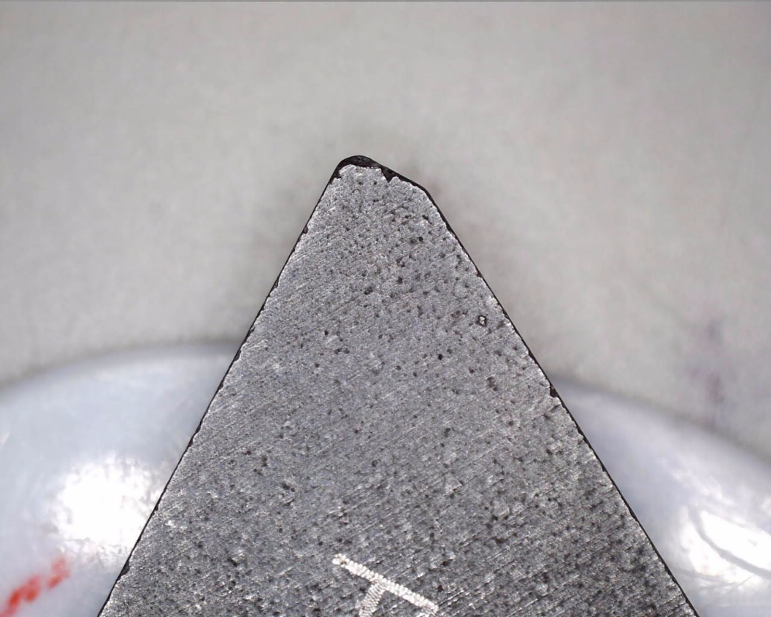
Cutting edge

Week 2
Triangular tool bit upper cutting face

Experiment
Short note on experiment

The researcher fristky used different surface textured toolbits. He then analysed the chips. The chips were analysed using micro celestron. Photos were clicked of all different chips.the expriemnt include 12 different toolbits.

Apparatus required
- Cnc machine
The machine is used for machining of workpiece sing different toolbits.the chips generatedf will then be analysed

- Micro celestron
The microscope is used for clicking photos of chips . photos are clicked from different angles and zoom levels.scales were used wit differnet zoom levels.the chips images will furthur be analyzed and used as research evidence.

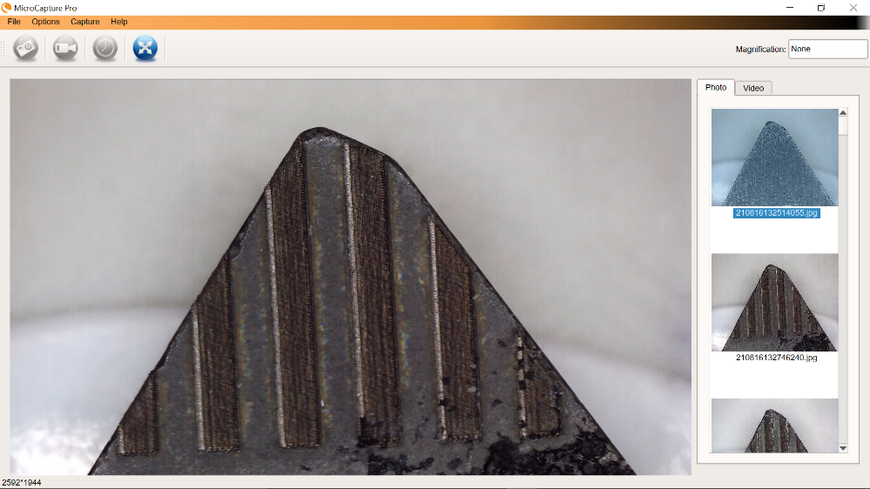

- Image j
The software is used for image calibration. The scales was set for different zoom levels.The bars were plotted of

Photos of toolbits
Before After

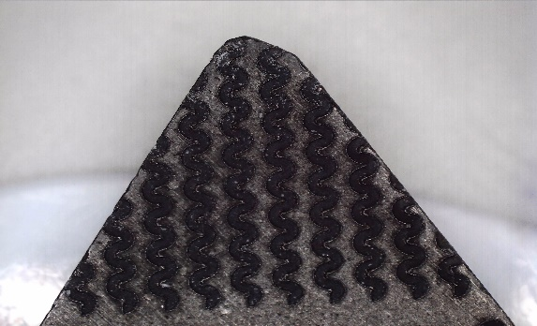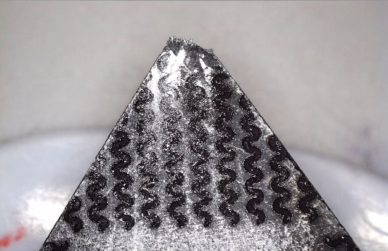

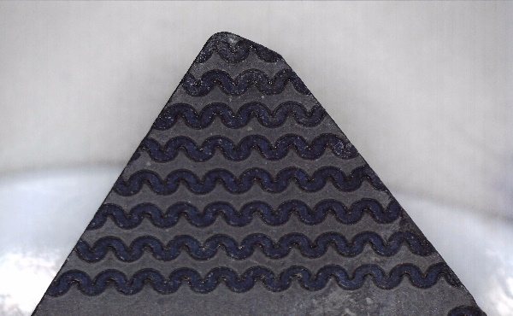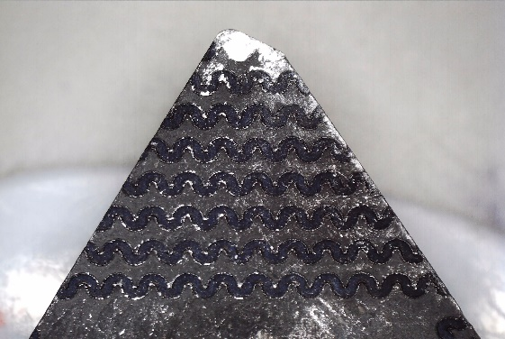

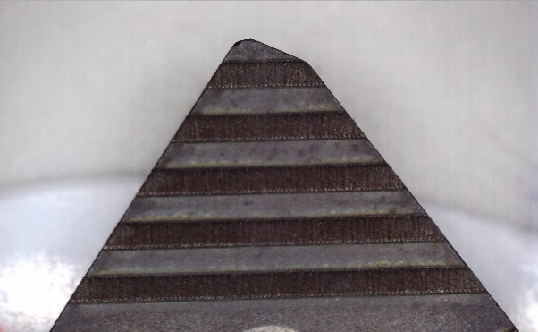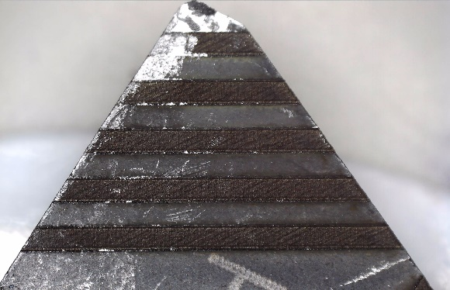

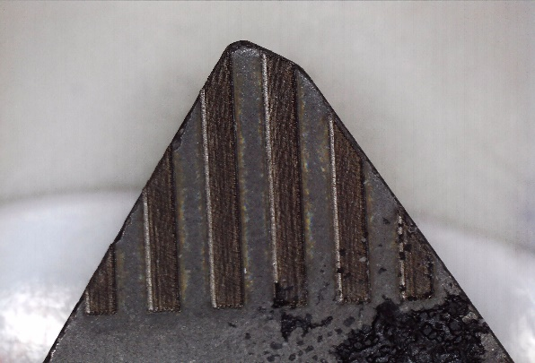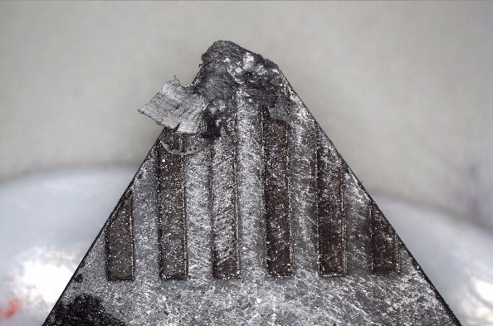

Week 4

Coordinate measuring machine

Coordinate measuring machine is a device use to trace the geometry of an object by tracking discrete points on objects using probe. Probe is a small pin like device moved by coordinates and track points. There are different types of probes used like mechanical. Laser and white light. Probe can be controlled manually or automatically depending on use and type of machine. Probe angle is also a parameter that can be adjusted in some machines. A three-dimensional coordinate system is defined with a specific reference point to as origin. Probe uses this coordinate system to track discrete points on physical objects.

Components

- base table
- workpiece
- probe
- probe controlling machine
- computer for controlling machine
- joystick
- control probe.

base
Workpiece table
probe
Controlling machine
Coordinate measuring machine

What it is used for before

The machine used to do what micro celestron microscope do now. It does 3d imaging of objects and click images.th device measures the geometry of physical objects by sensing discrete points on the surface of the object with a probe.
The machine is not used much now. The work done by can be done on modern machines. Advanced methods have come for 3d imaging like Lidar.


Monitor
Thread less axle
Cross roller guide

Touch probe

Joystick
Keyboard
CPU
Coordinate measuring machine Line diagram


What we did

- we use the micro hardness testing machine to find the hardness of tool bits.
- We used the machine software to find graph of indentation and Load
- we used the software to calculate Vickers hardness number, although many other constants can be calculated from this machine.


Stone plate for vibration free secure position
Measuring head HT2000
Contemplating plate
Support stand

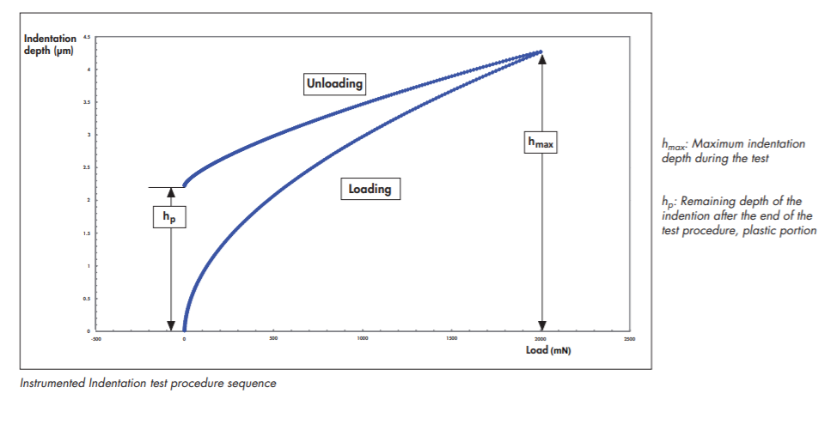
This is the kind of graph we get when we perform hardness test on any material. The graph tells us about deformation and how material is performing under loading. The graph can also tell us if we had performed experiment wrongly. If graph gives a distorted curve.
Stir casting

Stir casting is a liquid state method for the fabrication of composite material , in which a dispersed phase is mixed with a molten matrix metal by means of mechanical stiring . stir casting is the simplest and the most effective method of liquid state fabrication.

Procedure to use
- The varying quantities for metal composites is inserted in the crucible
- The crucible is then inserted in the furnace.
- The metal starts to melt
- The stirrer uses to stir the metal in crucible for uniform distribution of metal
- The metal is taken out from crucible
- The metal is allowed to cast in die.
Furnace

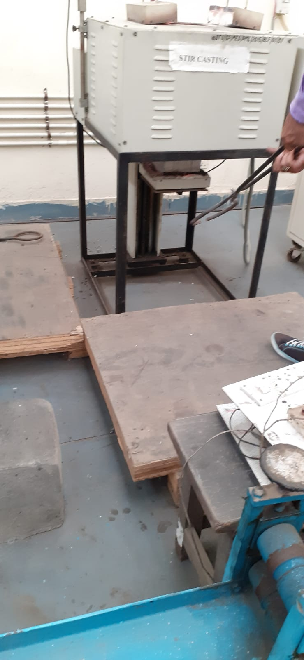
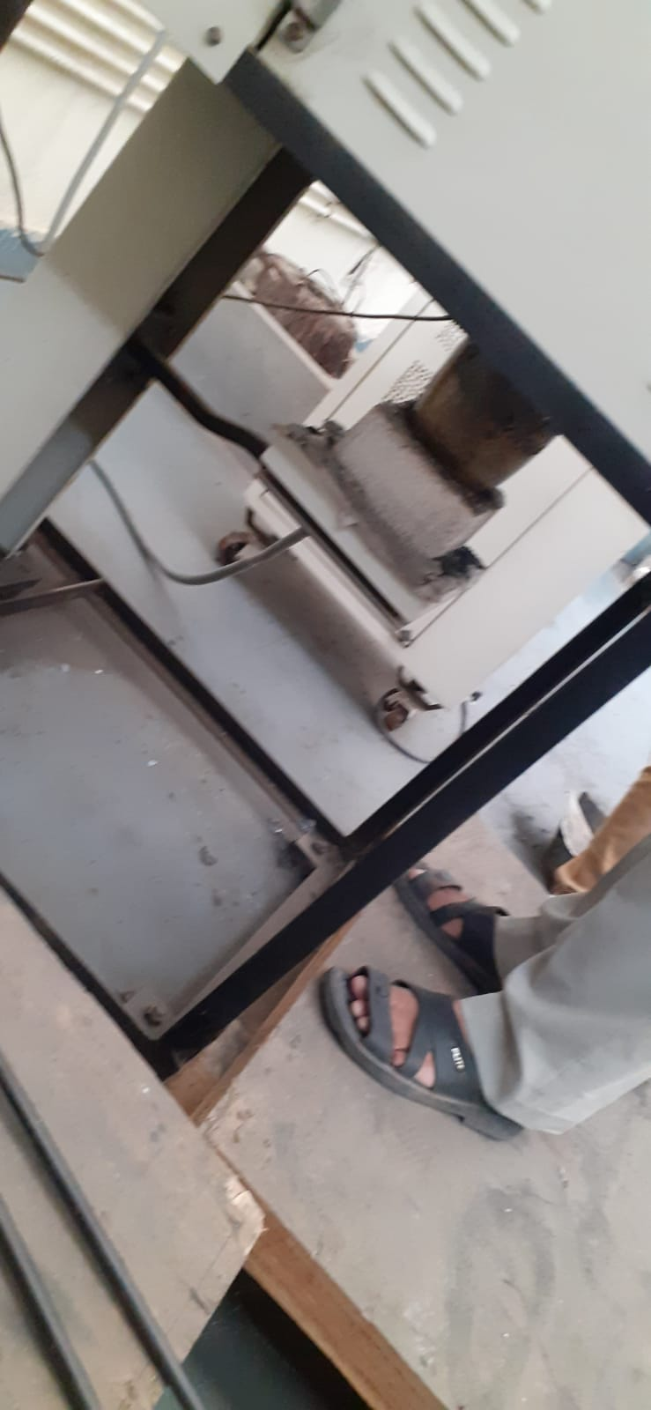
crucible

Residual stress analyzing machine




Components
- X-ray safety cabinet-The safety cabinet with interlocking protection is designed to protect users from x-ray exposure, cabinet leakage less than .1 Micro-Sievert/hour.
- Flexible arm with magnet stand- since the bottom face of the stand is strongly magnetic, it is easy to adjust the sensor unit position with flexible arm. Both X and Y axis are adjustable in a 50 mm range in steps with .01 mm resolution.
- Hand – Carry Case- This Hand- Carry Case can contains the complete standard set of the unit for the measurement.

- Electrochemical polisher-This Electrochemical polisher for the controlled removal of the metal surface layers without having minimum impact on stress.
Safety cabinet
Flexible arm

Electrochemical Polisher

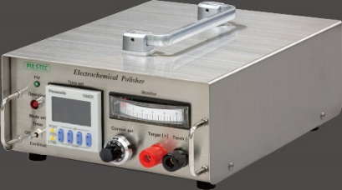 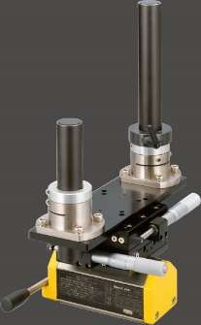 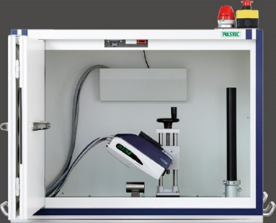
What we did
- We use the residual stress analyzer machine to calculate residual stress.
- If value comes out negative it is compressive stress and not damaging, of value comes out positive it is tensile stress. The more the tensile stress the unsafe the material is to failure.
- The graph was also generated by software with pdf illustrating all results of the materials.
- We measured residual stresses of tool bits.
- If the residual stress does not appear in values, it means you have done wrong experiment.

Conclusion

The experience I got from this internship is of paramount importance to me. The mentor Mr. Ramakant rana gave us practical knowledge and life lessons. I will never forget his meaningful advices. The experience will continue to support me in future life to come. I got a holistic view of research and engineering. The software I learned include image j, micro celestron, residual stress analyzer software and micro hardness testing machine software. Precision manufacturing lab under include a lot of machines. We worked on many machines. The details are explained above deeply. Apart from these machines we also got a chance of working in other labs. The machines we saw were CNC and coordinate measuring machine. While exploring the lab I four a four degree of freedom robotic arm. I will show a photo of it below. A heartful thank you to Mr. . Ramakant rana for choosing me for this internship.

